Mueller Matrix Imaging Polarimeter for UV Metrology

B. J. Daugherty
R. A. Chipman
S. McClain
University of Arizona College of Optical Science
1630 East University Boulevard
Tucson, AZ 85721

Abstract-The University of Arizona Polarization Laboratory with support from the Jet Propulsion Laboratory (JPL) has assembled and is currently calibrating a UV Mueller matrix imaging polarmeter (UV-MMIP). The desire for more accurate polarimetric and radiometric sensors drives the need for stringent polarization requirements and the ability to more precisely measure system and component polarization behavior. One such sensor is JPL’s Multiangle Spectropolarimetric Imager (MSPI), which requires highly controlled polarization behavior from UV wavelengths to the short wave IR. The UV polarization properties of components such as broadband coated mirrors, waveplates, dichroic filters, and polarizers often behave much differently than in visible light. The UV-MMIP is designed to provide rapid and accurate determination of the complete polarization properties of components, imaged at high spatial resolution.
The UV-MMIP is a dual rotating retarder polarimeter with components selected for best polarimetric precision between 250 nm and 500 nm. Polarization critical components include source, detectors, imaging optics, illumination optics, retarders, and polarizers. The back-illuminated CCD camera images at 512 x 512 pixel resolution, providing 40 micron resolution over a 2 cm field of view or as little as 1 micron resolution over a 500 micron field of view, with auxiliary UV-optimized microscope objectives. Both transmissive and reflective samples are accommodated. The entire 16-element Mueller matrix is measured on a pixel-by-pixel basis to an expected accuracy of 0.1%, matching or surpassing the accuracy of an existing visible light instrument functioning in the same laboratory. Automated data acquisition and analysis software provides detailed images of polarization characteristics including diattenuation, retardance, and depolarization.

I. INTRODUCTION

The design of the UV-MMIP focuses on meeting the requirements for polarization characterization of the MSPI system and its components. Beyond meeting these specific needs, the design aims to make the UV-MMIP into a comprehensive UV to VIS polarization metrology device. The set of requirements imposed by the MSPI project needs are: obtain Mueller matrix images with 0.5% accuracy, measure at wavelengths from 340nm to 500nm, and 40μm resolution at sample.
A Mueller matrix is a 4x4 matrix that fully describes the polarization altering properties of a sample. A Mueller matrix polarimeter measures Mueller matrices by illuminating a sample with known polarization states and then measuring the polarization of transmitted or reflected light. There are many different techniques for measuring Mueller matrices. One technique to achieve polarization controlled illumination and polarization sensitive detection utilizes a polarizer-retarder combination as a generator and a retarder-polarizer combination as an analyzer [1]. The generator modulates the illumination polarization by rotating a ~1/4 wave retarder following a polarizer; this produces polarization states ranging from linear to near-circular. The analyzer measures the irradiance of different polarization states by rotation a ~1/4 wave retarder in front of a polarizer; this creates an analyzer that transmits different states ranging from linear to near-circular. Using this technique for polarization control results in the well known dual rotating retarder polarimeter [2]-[3].
The UV-MMIP utilizes the dual rotating retarder scheme because it provides high accuracy and simpler calibration than many other techniques. The slower Mueller matrix acquisition time using this method is not a serious issue because there is no significant benefit in high speed measurements to characterizing the MSPI system and components.

II. SYSTEM DESCRIPTION
A. Overview
Four major subsystems interface to make the UV-MMIP a highly accurate polarimeter for UV polarimetric metrology as well as a fully automated measurement system capable of obtaining in-plane Mueller matrix BRDF data with minimal user input. A specular illumination system comprised of a fiber coupled xenon light source and condensing optics is optimized to provide the maximum illumination at the sample based on the length of the system and the critical aperture sizes. A dual rotating retarder polarization modulation system provides the polarization control. A back-illuminated CCD and a UV achromatic doublet comprise an imaging system capable of reaching the resolution requirements for measuring MSPI system components. The goniometric subsystem allows the UV-MMIP camera rotate around the sample from 180° to 20° while the sample rotates through 360° freely. Fig. 1 shows the 4 subsections of the UV-MMIP as they fit into the final system. The sample mounts onto a motorized stage not shown in Fig. 1.

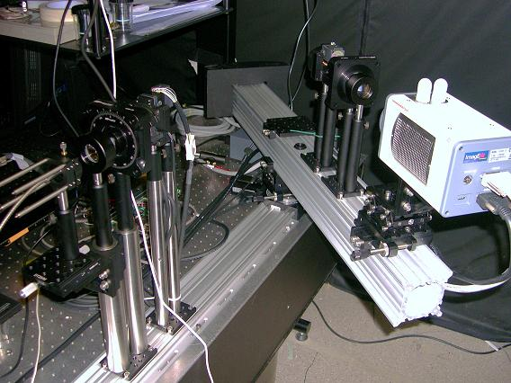
Imaging system
Illumination system
Polarization generator/ analyzer
Automation system
Fig. 1. The UV-MMIP with its 4 subsystems highlighted.

B. Illumination system
The illumination system uses a fiber coupled 175W xenon light source and a 50mm focal length UV achromatic doublet. To increase the coupling efficiency the xenon source couples to a large 1mm fiber with a numerical aperture (NA) of 0.22. The fiber output fixes the maximum etendue of the UV-MMIP The polarizers are the limiting aperture with a diameter of 20mm. Fig. 2 shows the first order optical layout of the UV-MMIP.

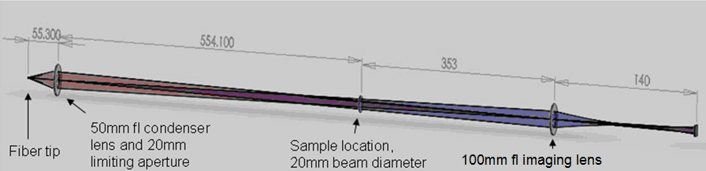
Fig. 2. The first order optical layout of the UV-MMIP. The condenser lens images the fiber tip onto the imaging lens, which maximizes the etendue of the UV-MMIP.

The xenon light source provides good illumination down to about 250nm where its output begins to fall off as shown in Fig. 3. An 1/8 meter monochromator controls the output wavelength of the source. The output bandwidth can be varied from 1nm to 20nm.

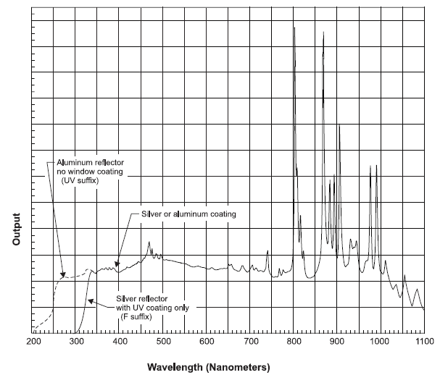
Fig. 3. Spectrum of xenon light source [4]

C. Imaging system
The detector is a Hamamatsu C9100-13 EMCCD optimized for UV. The camera’s quantum efficiency extends down to wavelengths of about 200nm, as shown in Fig. 4, making it ideal for this application.

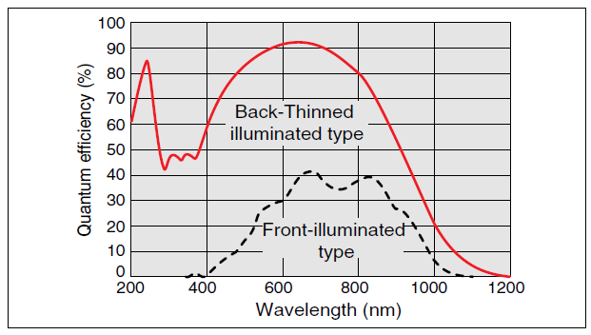
Fig. 4. Quantum efficiency of C9100-13 EMCCD shown in red. Taken from Hamamatsu website.

The camera has 512 x 512 square pixels, each 16 μm. The single pixel irradiance noise arises from the various noise sources in the EMCCD camera. The readout error and the dark current account for about 125 electrons of noise for a typical camera exposure in the UV-MMIP. The EMCCD’s full well is 370,000 electrons. For a measurement at ½ of the full well depth the measurement error is calculated by combining the readout error and dark noise with the shot noise to give a total error of 0.2% [5].
The sample is usually imaged onto the camera with a 100 mm focal length UV achromat. This images the 20mm diameter sample plane onto an 8mm spot on the detector providing a nominal resolution of 40 μm. The resolution can be changed by adding other optical elements to the imaging system. For example we also operate with a pair of microscope objectives placed on each side of the sample providing resolution of about 1 μm.

D. Polarization Control
The polarization generator uses a polarizer in front of a rotating retarder to create a number of different elliptically polarized states. An analyzer consisting of a rotating retarder followed by a polarizer analyzes different elliptical states. A typical measurement uses 64 images acquired at different generator and analyzer configurations to calculate the Mueller matrix of the sample. The generator retarder rotates 5 times faster than the analyzer retarder during such a measurement. It is important to choose polarizers and retarders that operate well at the UV wavelengths of interest.
The UV-MMIP uses RedOptronic α-BBO Glan-Thompson polarizers due to their large 15º field of view, their ability to perform in the UV down to 220 nm, and their availability in sizes up to 20mm. The polarizer have been AR coated with coatings optimized for 350 nm. Each polarizer mounts into a lockable manual rotation stage to allow easy alignment adjustment.
The retarders must be designed to optimize their performance over the wavelength range of interest. One common metric for describing the performance of a polarimeter, the condition number of the data reduction matrix, provides a convenient method to determine the optimal retarders for the UV-MMIP. Condition number analysis determines that 130 nm retarders (1/4 wave at 520nm) result in the best polarimetric performance over the wavelength range of 350nm to 500nm. Fig. 5 shows a plot of the condition number vs wavelength. Smaller condition numbers correlate to better polarimeter performance. The retardance of 130 nm balances the condition number between the short and long wavelengths [6].

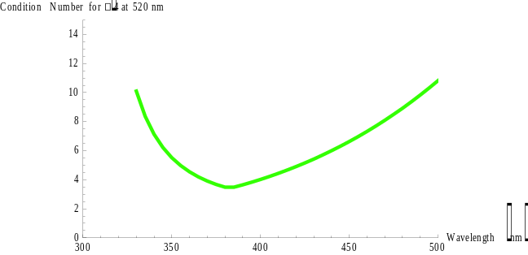
Fig. 5. Condition number of the UV-MMIP when using 130nm retarders.

The retarder rotation is motor controlled and automated using Oriental motorized rotation stages which have an absolute accuracy of 0.067° and a maximum speed of 1200°/s.

E. Goniometric System
Polarimetric and ellipsometric sample measurements at a large number of angles are required for the proper characterization of thin films in the UV. A computer controlled goniometer system expedites measurements at a large number of angles.
The UV-MMIP camera is mounted on a motorized boom which rotates the camera around the sample and a second motor which rotates the sample so the motor and sample rotate to any angle of incidence and collection in a programmable manner. The motor control system consists of a Newport motion controller and two Newport stages. A user interface program in LabView controls the polarimeters operation and the initial steps in the data reduction. There is a specular scan mode which measures specular reflection over the angle range and wavelength range. The BRDF mode performs measurements at a set of scattered light angles read from a custom-specified table of angles and operating conditions.

III. INITIAL MESUREMENTS AND TESTING

A. Preliminary Mueller Matrix Measurements
UV-MMIP construction was just completed in May 2010. Calibration and preliminary measurements are producing promising Mueller matrix data. The data discussed in this paper corresponds to the first calibration and data acquisition performed at 380nm.
Fig. 6, Fig. 7, and Fig. 8 show results of an air measurement using the UV-MMIP. Fig. 6 shows the resulting Mueller matrix, which looks vary close to an identity matrix as expected. To further examine the quality of our air measurement we look specifically at how accurately we have measured the diattenuation magnitude and retardance magnitude. Fig. 7 shows that the diattenuation magnitude varies from about 0.8% to 1.1% through the image. Fig. 8 shows that the retardance varies from 0.05° to 0.2° through the image. The accuracy of the preliminary measurements is not at the 0.1% level but we still have significant calibration and testing to finish that will improve the accuracy of the UV-MMIP.

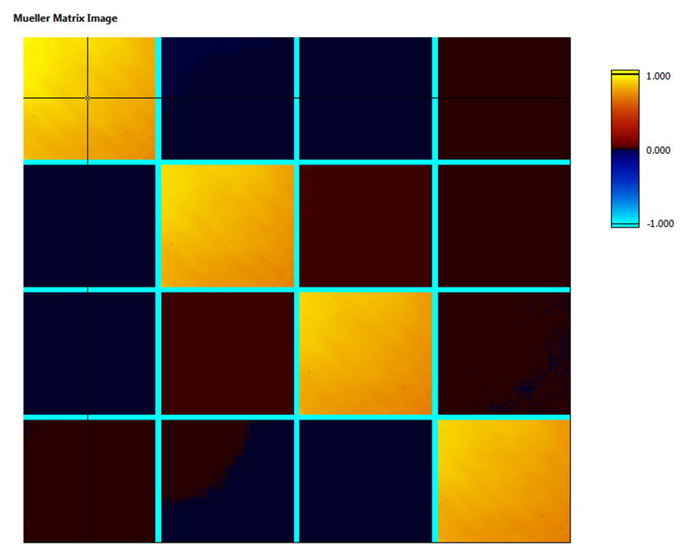
Fig. 6. Mueller matrix resulting from an air measurement using the UV-MMIP. Ideally the Mueller matrix of air should be the identity matrix. The matrix shown here is very close to the identity matrix.
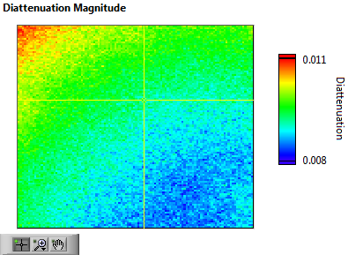
Fig. 7. The diattenuation magnitude resulting from an air measurement using the UV-MMIP.

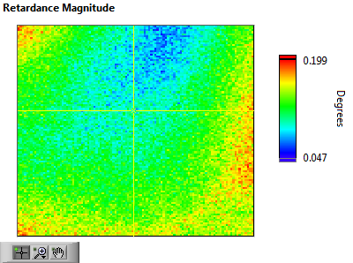
Fig. 8. The retardance magnitude resulting from an air measurement using the UV-MMIP.

B. Early Testing
One calibration test demonstrates that the illumination system is stable within a standard deviation 0.4% across our bandwidth of interest. Fig. 9 shows the results of the light source stability test performed on the UV-MMIP illumination system. The measurements are performed by acquiring 64 measurements at each wavelength over a 4 minute period of time. This models the way data will be collected in a typical Mueller matrix measurement using the UV-MMIP.

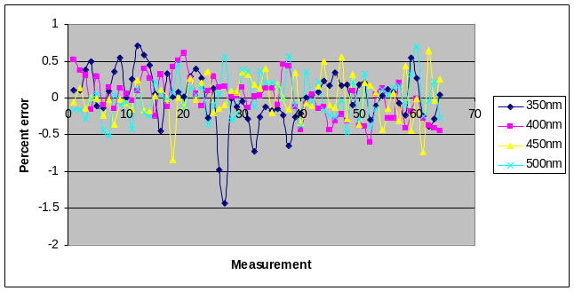
Fig. 9. Results of source stability testing.

C. Future Tests
The UV-MMIP requires extensive testing and calibration to reach its optimal performance, including camera linearity and monochromator calibration, and polarization element calibration.

IV. CONCLUSION

The University of Arizona Polarization Laboratory in collaboration with the Jet Propulsion Laboratory has assembled a state of the art ultra-violet Mueller matrix polarimeter that expands our abilities to measure polarization critical components for innovative projects such as the MSPI camera. Initial testing shows very promising results.

REFERENCES

[1] R. M. A. Azzam, “Photopolarimetric measurement of the Mueller matrix by Fourier analysis of a single detected signal,” Opt.
Lett. Vol. 2, 148–150 (1977).

[2] R. A. Chipman, “Polarimetry,” in Handbook of Optics, 2nd ed.,
M. Bass, ed. (McGraw-Hill, New York, 1995), Vol. 2, Chap. 2.

[3] D. H. Goldstein and R. A. Chipman, “Error analysis of a Mueller matrix polarimeter,” J. Opt. Soc. Am. A Vol. 7, 693–700 (1990).

[4] Spectral Products webpage, http://www.spectralproducts.com/catalog/images/Xe_Spectrum.jpg

[5] Hamamatsu C9100-13 Specification Sheet, http://sales.hamamatsu.com/assets/pdf/hpspdf/e_orca_em.pdf, Page 3 (2010).

[6] Matthew H. Smith, "Optimization of a Dual-Rotating-Retarder Mueller Matrix Polarimeter," Appl. Opt. Vol. 41, 2488-2493 (2002)

